Problem 1

Write a program to print your name on screen.

Problem 2

Write a program to ask the user to enter his/her name and print it on screen

Problem 3

Write a program to ask the user to enter a number, then Print “ODD” if its odd, Or “Even” if its even

Problem 004 Hire a Driver Case1

Write a program to ask the user to enter his/her:

• Age

• Driver license

Then Print “Hired” if his\her age is grater than 21 and s/he has a driver license, otherwise Print “Rejected.

Problem 005 Hire a Driver Case2

Write a program to ask the user to enter his/her:

• Age

• Driver license

• Has Recommendation!

Then Print “Hired”

if

his\her age is grater than 21

and s/he has a driver license,

otherwise Print “Rejected” Or Hire him\her without conditions

Problem 006 FullName

Write a program to ask the user to enter:

• First Name

• Last Name

Then Print Full Name on screen.

Example Input:

Mohammed

Abu Hadhoud

Output

Mohammed Abu-Hadhoud

Problem 007 Half Number

Write a program to ask the user to enter:

• Number

Then Print the “Half of the <Number> is <???>”.

Example Inputs:

60

50

Outputs :

Half of 60 is 30

Half of 50 is 25

Problem 008 Mark Pass Fail

Write a program to ask the user to enter:

• Mark

Then Print the “PASS” if mark >=50, otherwise print “Fail”

Example Inputs:

45

Outputs

Fail

Problem 009 Sum of 3 numbers

Write a program to ask the user to enter:

• Number1, Number2, Number3

Then Print the Sum of entered numbers

Example Inputs:

10

20

30

Outputs

60

Proble 10 :Average of 3 Marks

Write a program to ask the user to enter:

• Mark1, Mark2, Mark3

Then Print the Average of entered Marks

Example Inputs:

90

80

70

Outputs

80

Problem 011 Average Pass Fail

Write a program to ask the user to enter:

• Mark1, Mark2, Mark3

Then Print the Average of entered Marks, and print “PASS” if average>=50, otherwise print “FAIL”

Example Inputs:

90

80

70

Outputs

80

PASS

Problem 012 Max of 2

Write a program to ask the user to enter:

• Number1 , Number2

Then Print the Max Number

Example Inputs:

10

20

Outputs

20

Problem 013 Max of 3

Write a program to ask the user to enter 3 numbers:

• A

• B

• C

Then Print Max number.

Example Inputs:

30

10

20

Outputs:

30

Problem 014 Swap Numbers

Write a program to ask the user to enter:

• Number1

• Number2

Then print the two numbers ,

then Swap the two numbers and print them

Example Inputs:

10

20

Outputs:

10

20

20

10

Problem 015 Rectangle Area

Write a program to calculate rectangle area and print it on the screen.

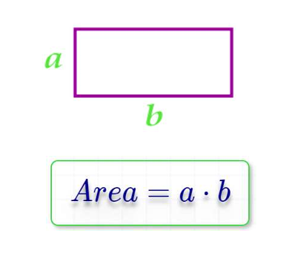Example Inputs:

10

20

Outputs :

200

Problem 016 Rectangle area Through Diagonal and side Area

Write a program to calculate rectangle area through diagonal and side area of rectangle and print it on the screen.

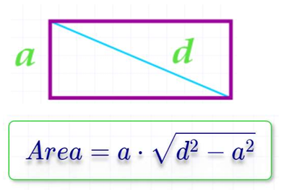The use should enter:

A

D

Example Inputs:

5

40

Outputs

198.43

Problem 017 Triangle Area:

Write a program to calculate triangle area then print it on the screen.

The user should enter:

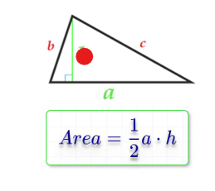a

h

Example Inputs:

10

8

Outputs :

40

Problem 018 Circle Area

Write a program to calculate circle area then print it on the screen.

The use should enter:

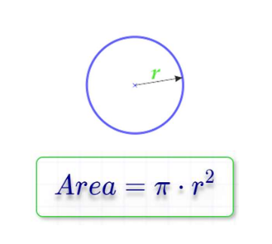R

Example Inputs:

5

Outputs

78.54

Problem: 019 Circle Area Through Diameter

Write a program to calculate circle area through diameter,

then print it on the screen.

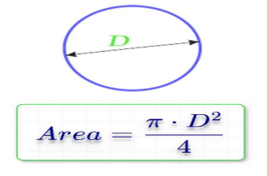The use should enter:

D

Example Inputs:

10

Outputs

78.54

Problem 020 Circle Area Inscribed in a Square

Write a program to calculate Circle area inscribed in a square,

then print it on the screen.

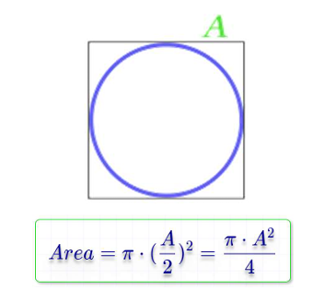The use should enter:

A

Example Inputs:

10

Outputs :

78.54

Problem 021 Circle Area Along the Circumference

Write a program to calculate circle area along the circumference,

then print it on the screen.

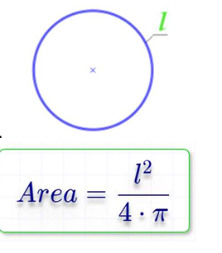

The use should enter: L

Example Inputs:

20

Outputs :

31.831

Problem 022 Circle Area Inscribed in an Isosceles Triangle

Write a program to calculate circle area Inscribed in an Isosceles Triangle,

then print it on the screen.

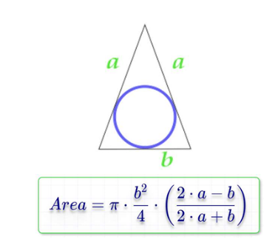

The use should enter:

a

b

Example Inputs:

20

10

Outputs :

47.124

Problem 023 Circle Area circle Described Around an Arbitrary Triangle

Write a program to calculate circle area Inscribed in an Isosceles Triangle,

then print it on the screen.

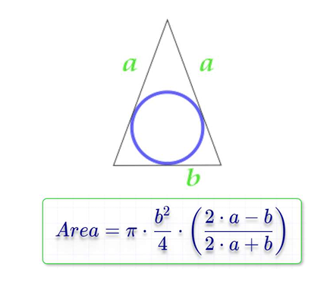The use should enter:

a

b

Example Inputs:

20

10

Outputs:

47.124

Problem 024 Validate Age Between 18 and 45:

Write a program to ask the user to enter :

• Age

If age is between 18 and 45 print “Valid Age” otherwise print “Invalid Age”

Problem 025 Read Until Age Between

Write a program to ask the user to enter :

• Age

If age is between 18 and 45 print “Valid Age” otherwise print “Invalid Age” and re-ask user to enter a valid age.

Note: You should keep asking user to enter a valid age until s/she enters it.

Problem 026 Print Numbers from 1 to N

Write a program to print numbers from 1 to N.

Input

10

Outputs

1

2

3

4

5

6

7

8

9

10

Problem 027 Print Numbers from N to 1

Write a program to print numbers from N to 1.

Input

10

Outputs :

10

9

8

7

6

5

4

3

2

1

Problem 028 Print Sum Odd Numbers from 1 to N

Write a program to Sum odd numbers from 1 to N.

Input

10

Outputs :

25